<https://www.cloudskillsboost.google/focuses/2794?parent=catalog>

# Lab 1 A Tour of Google Cloud Hands-on Labs

## Projects in the **Google Cloud Console (GCC)**

* The upper-left corner of the central pane contains a card labeled Project info that looks like this:

* Project has a name, ID, number - are frequently used when interacting with **Google Cloud services (GCS)**.

### **Task 2: View all projects -** You actually have access to more than one Google Cloud project.

* + In the **GCC** title bar, next to your project name, click the drop-down menu.
  + In the **Select a project** dialog, click **All**. It list of projects includes a "Qwiklabs Resource" project.

* Organizations use Google Cloud in different ways, so projects are a good method for organizing cloud computing services (by team or product, for example.)
* The "Qwiklabs Resources" project contains files, datasets, and machine images for certain labs and can be accessed from every Google Cloud lab environment.
* "Qwiklabs Resources" is shared (read only) with all users, which means cannot delete or modify it.

## **Navigation menu and services -** The GCC title bar contains a button labeled with a three-line icon:

* Clicking this icon opens (or hides) the menu to quick access to Google Cloud's core services.

* There are seven categories of Google Cloud services:
  + **Compute:** A variety of machine types that support any type of workload. The different computing options let you decide how much control you want over operational details and infrastructure.
  + **Storage:** Data storage and database options for structured or unstructured, relational or non relational data.
  + **Networking:** Services that balance application traffic and provision security rules.
  + **Cloud Operations:** A suite of cross-cloud logging, monitoring, trace, and other service reliability tools.
  + **Tools:** Services that help developers manage deployments and application build pipelines.
  + **Big Data:** Services that allow you to process and analyze large datasets.
  + **Artificial Intelligence:** A suite of APIs that run specific artificial intelligence and machine learning tasks on Google Cloud.
* [This link](https://cloud.google.com/docs/overview/cloud-platform-services#top_of_page) takes you to documentation that covers each of these categories in more detail.

## **Roles and permissions**

* + GC also contains a collection of permissions and roles that define who has access to what resources.
  + You can use the [Cloud Identity and Access Management (Cloud IAM)](https://cloud.google.com/iam/) service to inspect and modify these roles and permissions.

### **Task 3: View your roles and permissions**

* + On the **Navigation menu** (Navigation menu), click **IAM & Admin**. This opens a page that contains a list of users and specifies permissions and roles granted to specific accounts.

* Find the "@qwiklabs" username you signed in with:

* The Editor Role, which is one of three basic roles offered by Google Cloud.
* Basic roles set project-level permissions and, unless otherwise specified, control access and management to all Google Cloud services.
* The following table pulls definitions from the [roles documentation](https://cloud.google.com/iam/docs/understanding-roles/#primitive%5C_roles), which gives a brief overview of viewer, editor, and owner role permissions:

|  |  |
| --- | --- |
| **Role Name** | **Permissions** |
| roles/viewer | Permissions for read-only actions that do not affect state, such as viewing (but not modifying) existing resources or data. |
| roles/editor | All viewer permissions, plus permissions for actions that modify state, such as changing existing resources. can't add or delete members |
| roles/owner | All editor permissions and permissions for the following actions: manage roles and permissions for a project and all resources within the project; set up billing for a project. |

## **APIs and services**

* + Google Cloud APIs are a key part of Google Cloud.
  + Cloud APIs use resource-oriented design principles as described in the [API Design Guide](https://cloud.google.com/apis/design/).
* When you create your own Google Cloud projects, you will have to enable certain APIs yourself.
* Most Cloud APIs provide you with detailed information on your project’s usage of that API, including traffic levels, error rates, and even latencies, which helps you quickly triage problems with applications that use Google services.

### **Task 4: View available APIs**

* 1. On the **Navigation menu** (Navigation menu), click **APIs & Services > Library**. The left pane, under the header **CATEGORY**, displays the different categories available.

* + - In the API search bar, type **Dialogflow**, click **API** description page opens.Click **Enable**.

# <https://www.cloudskillsboost.google/focuses/3563?parent=catalog>

# Lab 2 Creating a Virtual Machine

### **Cloud Shell**

### It’s a VM that is loaded with development tools.

### It offers a persistent 5GB home directory and runs on the Google Cloud.

### Cloud Shell provides command-line access to your Google Cloud resources.

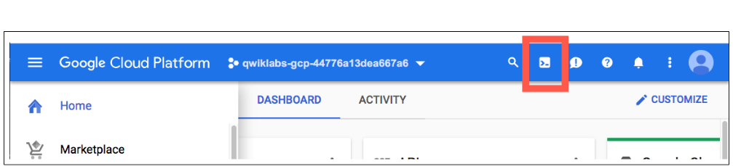

* + When it connected, you are already authenticated, and the project is set to your PROJECT\_ID.

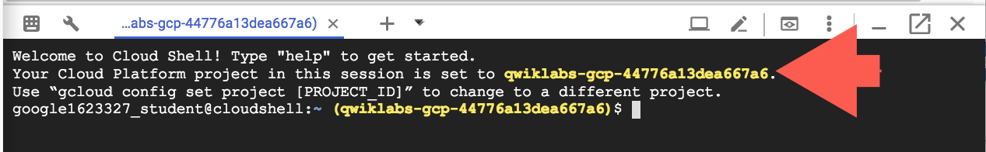

* + gcloud is the command-line tool for Google Cloud. It comes pre-installed on Cloud Shell and supports tab-completion.
  + List the active account name with this command: gcloud auth list
  + List the project ID with this command: gcloud config list project
  + For full documentation of gcloud see the [gcloud command-line tool overview](https://cloud.google.com/sdk/gcloud" \t "_blank).

### **Understanding Regions and Zones**

* + Certain Compute Engine resources live in regions or zones.
  + A region is a specific geographical location where you can run your resources.
  + Each region has one or more zones.
  + For example, the us-central1 region has zones us-central1-a, us-central1-b, us-central1-c, and us-central1-f.

* Resources that live in a zone are referred to as zonal resources.
* VM Instances and persistent disks live in a zone.
* To attach a persistent disk to a VM instance, both resources must be in the same zone.
* Similarly, if you want to assign a static IP address to an instance, the instance must be in the same region as the static IP.

## Task 1: Create a new instance from the Cloud Console

* + create new pre-defined machine types with Compute Engine from the Cloud Console.
  + In the Cloud Console, on the **Navigation menu** (Navigation menu), click **Compute Engine** > **VM Instances**.
  + To create a new instance, click **CREATE INSTANCE**.
  + There are many parameters you can configure when creating a **new instance**. Use the following for this lab:

|  |  |  |
| --- | --- | --- |
| **Field** | **Value** | **Additional Information** |
| **Name** | **gcelab** | Name for the VM instance |
| **Region** | **us-central1 (Iowa)** | For more information about regions, see [Regions and Zones](https://cloud.google.com/compute/docs/zones). |
| **Zone** | **us-central1-f** | **Note:** Remember the zone that you selected: you'll need it later. For more information about zones, see [Regions and Zones](https://cloud.google.com/compute/docs/zones). |
| **Series** | **N1** | Name of the series |
| **Machine Type** | **2 vCPU** | This is an (n1-standard-2), 2-CPU, 7.5GB RAM instance. Several machine types are available, ranging from micro instance types to 32-core/208GB RAM instance types. For more information, see [Machine Types](https://cloud.google.com/compute/docs/machine-types). **Note:** A new project has a default [resource quota](https://cloud.google.com/compute/docs/resource-quotas), which may limit the number of CPU cores. You can request more when you work on projects outside this lab. |
| **Boot Disk** | **New 10 GB balanced persistent disk** **OS Image: Debian GNU/Linux 10 (buster)** | Several images are available, including Debian, Ubuntu, CoreOS, and premium images such as Red Hat Enterprise Linux and Windows Server. For more information, see Operating System documentation. |
| **Firewall** | **Allow HTTP traffic** | Select this option in order to access a web server that you'll install later. **Note:** This will automatically create a firewall rule to allow HTTP traffic on port 80. |

* Click **Create,** the new virtual machine is listed on the **VM Instances** page.
* To use **SSH** to connect to the VM, in the row for your machine, click **SSH**.
* This launches an SSH client directly from your browser.



## Task 2: Install an NGINX web server,

## one of the most popular web servers in the world, to connect your VM to something.

* + In the SSH terminal, to get root access, run the following command: sudo su -
  + As the root user, update your OS: apt-get update
  + Install **NGINX**: apt-get install nginx -y
  + Confirm that **NGINX is running**: ps auwx | grep nginx
  + To see the web page, return to the Cloud Console and click the **External IP** link .



## Task 3: Create a new instance with gcloud

* + Instead of using the Cloud Console to create a VM instance, use the command line tool gcloud, which is pre-installed in [Google Cloud Shell](https://cloud.google.com/developer-shell/#how_do_i_get_started).
  + Cloud Shell is a Debian-based virtual machine loaded with all the development tools you'll need (gcloud, git, and others) and offers a persistent 5-GB home directory.
  + **I**n the Cloud Shell, use gcloud to create a new vm instance from the command line:

gcloud compute instances create gcelab2 --machine-type n1-standard-2 --zone us-central1-f

* The new instance has these default values:
  + The latest [Debian 10 (buster)](https://cloud.google.com/compute/docs/images#debian) image.
  + The n1-standard-2 [machine type](https://cloud.google.com/compute/docs/machine-types). you can also specify a [custom machine type](https://cloud.google.com/compute/docs/instances/creating-instance-with-custom-machine-type).
  + root persistent disk with the same name as the instance; the disk is automatically attached to the instance.
* To see all the defaults, run: gcloud compute instances create --help
* **Note:** You can set the default region and zones that gcloud uses if you are always working within one region/zone and you don't want to append the --zone flag every time. To do this, run these commands:
  + gcloud config set compute/zone ...
  + gcloud config set compute/region ...
* To exit help, press **CTRL + C**.
* Te **Navigation menu**, click **Compute Engine > VM instances**. Your 2 new instances should be listed.

* You can also use SSH to connect to your instance via gcloud. Make sure to add your zone, or omit the --zone flag if you've set the option globally: gcloud compute ssh gcelab2 --zone us-central1-f
  + Type **Y** to continue.
  + Press **ENTER** through the passphrase section to leave the passphrase empty.
  + After connecting, disconnect from SSH by exiting from the remote shell: exit

# Cloud IAM (Identity and Access Management): Qwik Start

## Setup for two users to illustrate IAM policies and what permissions are available for specific roles.

* In the panel on the left-hand side of your lab, you see a list of credentials that resembles the following:

* Notice that there are two usernames: Username 1 and Username 2. These represent identities in Cloud IAM, each with different access permissions allocated to them.
* These "roles" set constraints on what you can and cannot do with Google Cloud resources in the project you've been allocated.

### **Sign in to Cloud Console as the first user, then the second user**

* You should now have two Cloud Console tabs open in your browser—one signed in with Username 1 and the other with Username 2.

### **View or reset the user in a browser tab**

* + Occasionally, a user is overwritten in a browser tab or you may be confused about which user is signed into which browser tab.
  + To view which user in signed into a browser tab, hover over your Avatar to view your username in that browser tab.

* To reset which user is signed and click **Sign out** to sign out.
* Return to the **Username 1** Cloud Console page.
* Select **Navigation menu** > **IAM & Admin** > **IAM**. You are now in the "IAM & Admin" console.
* Click **+ADD** button at the top of the page and explore the project roles associated with Projects by clicking on the "Select a role" dropdown menu:

* You should see Browser, Editor, Owner, and Viewer roles - primitive roles in Google Cloud.
* Primitive roles set project-level permissions and unless otherwise specified, they control access and management to all Google Cloud services.

|  |  |
| --- | --- |
| **Role Name** | **Permissions** |
| roles/viewer | Permissions for read-only actions that do not affect state, such as viewing (but not modifying) existing resources or data. |
| roles/editor | All viewer permissions, plus permissions for actions that modify state, such as changing existing resources. |
| roles/owner | All editor permissions and permissions for the following actions:   * Manage roles and permissions for a project and all resources within the project. * Set up billing for a project. |
| roles/browser (beta) | Read access to browse the hierarchy for a project, including the folder, organization, and Cloud IAM policy. This role doesn't include permission to view resources in the project. |

* Username 1 has Project owner permissions.

## Explore editor roles

## Now switch to the **Username 2** console.

## Navigate to the IAM & Admin console, select **Navigation menu** > **IAM & Admin** > **IAM**.

## Search through the table to find Username 1 and Username 2 and examine the roles they are granted. You should see something like this:

* You should see: Username 2 has the "Viewer" role granted to it.
* The **+ADD** button at the top is grayed out—if you try to click on it you get the following message:

* Switch back to the **Username 1** console for the next step.

### **Create a** Cloud Storage **bucket**

* 1. Create a bucket with a unique name. From **menu** > **Cloud Storage** > **Browser ->** **CREATE BUCKET**.
  2. Update the following fields, leave all others at their default values:

|  |  |
| --- | --- |
| **Property** | **Value** |
| **Name**: | globally unique name (create it yourself!) and click ***CONTINUE***. |
| **Location Type:** | Multi-Region |

* 1. Click **CREATE**. On the Bucket Details page click **UPLOAD FILES** button.
* Rename the file ‘sample.txt'.
* Switch to the **Username 2** console.
  1. From **menu** > **Cloud Storage** > **Browser**. Verify that this user can see the bucket.
  2. Username 2 has the "Viewer" role which allows them read-only actions.
* Remove project access
  1. Switch to the **Username 1** console.
  2. **Remove Project Viewer for Username 2**
  3. **menu** > **IAM & Admin** > **IAM**. Then click the pencil icon next to **Username 2**.

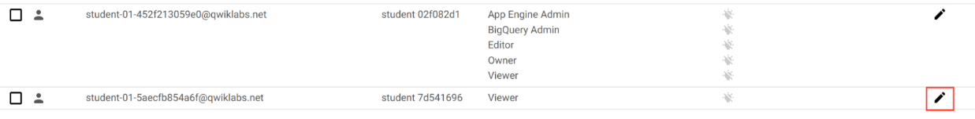

* 1. Remove Project Viewer access for **Username 2** by clicking the trashcan icon next to the role name. Then click **SAVE**.

* 1. Notice that the user has disappeared from the list! The user has no access now.

### **Verify that Username 2 has lost access**

* 1. Switch to **Username 2, navigate Navigation menu** > **Cloud Storage** > **Browser**.
  2. You should see a permission error.

## Add Storage permissions

* 1. Login **Username 1** console In the Console, select **Navigation menu** > **IAM & Admin** > **IAM**.
  2. Click **+ ADD** button and paste the **Username 2** name into the New principals field.
  3. In the **Select a role** field, select **Cloud Storage** > **Storage Object Viewer** from the drop-down menu.
  4. Click **SAVE**. Verify access, Switch to the **Username 2** console. You'll still be on the Storage page.
* Click the **Activate Cloud Shell** icon to open the Cloud Shell command line. If prompted click **Continue**.
* Graphical user interface, application, icon

  Description automatically generated
* Open up a Cloud Shell session and then enter the command, replace [YOUR\_BUCKET\_NAME] with the name of the bucket you created earlier: gsutil ls gs://[YOUR\_BUCKET\_NAME]

## Create and Manage Cloud Resources: Challenge Lab

https://www.cloudskillsboost.google/focuses/10258?parent=catalog